   | BHARAT SANCHAR NIGAM LIMITED  (A Government of India Enterprise)  (Revenue Management Branch- CFA)  Corporate Office  Room No.216, II floor, Eastern Court  Janpath, NEW DELHI-110 001
No.18-2/2012-LOP (BSNL)/Rlgs/TR Dated 26-10-2012
To
1. The Chief General Manager, ITPC, Pune.
2. The Chief General Managers
All Telecom Circles/Chennai and Kolkata Metro Telephone Districts.

Subject: Revision of Billing Procedure for telecom facilities provided to Hon’ble MPs by BSNL.
ITPC Pune has raised the following points regarding the Revision of Billing Procedure for telecom facilities provided to Hon’ble MPS by BSNL circulated vide this office letter of even No. dated 13-09-2012.
1 As per Para 7 of the letter dated 13-9-2012 , the payment details will be transferred to payment management system (PMS) by LOP. In this connection this to intimate that the payment details can not be transferred to PMS automatically and the payment details need to be fed manually / uploaded through the front end interface in PMS. This job can not be done by Data Centre directly.
2. The FMC in respect of BB Plan ULD 1000 has been communicated as Rs.833 and the same is Rs.1000/- as per the letter dated 3-11-2010. It may be confirmed that FMC of the BB Plan ULD 1000 has been modified as Rs.833.
3. The date of effect of the consolidated tariff order is 1-10-2012. However, the revised billing procedure mentioned “revised procedure will be given effect to from the bills generated by billing centres from 1-10-2012” Both are contradicting.
The points raised by ITPC, Pune have been examined and clarified as below.
1. In feeding the payment particulars in PMS , the circles will make arrangement for feeding the payment details pertains to the connections provided to Hon’ble MPS in their Circle by nominating any one SSA in the circle for this purpose. The payment will be fed in PMS by the circle as soon as the ATC is received from the Corporate Office.
2. It is hereby confirmed that FMC in respect of Plan ULD 1000 provided to Hon’ble MPs Rs. Rs. 833.
3. The tariff implementation date is hereby modified as 1-09-2012 instead of 1-10-2012 as there no change in the tariff and the tariff order is nothing but the consolidated order of existing tariff.
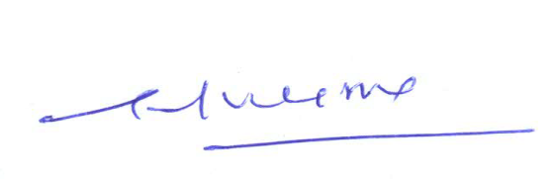

G.P.Verma
M (Finance-CFA)

